DevOps Assignment -5

GitHub CI/CD Pipeline

Anisha S

22BCS008

1. Create an index.html file.

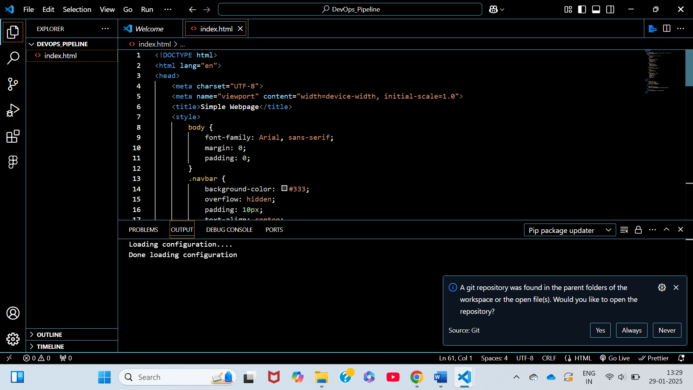

1. Create a repository in GitHub.

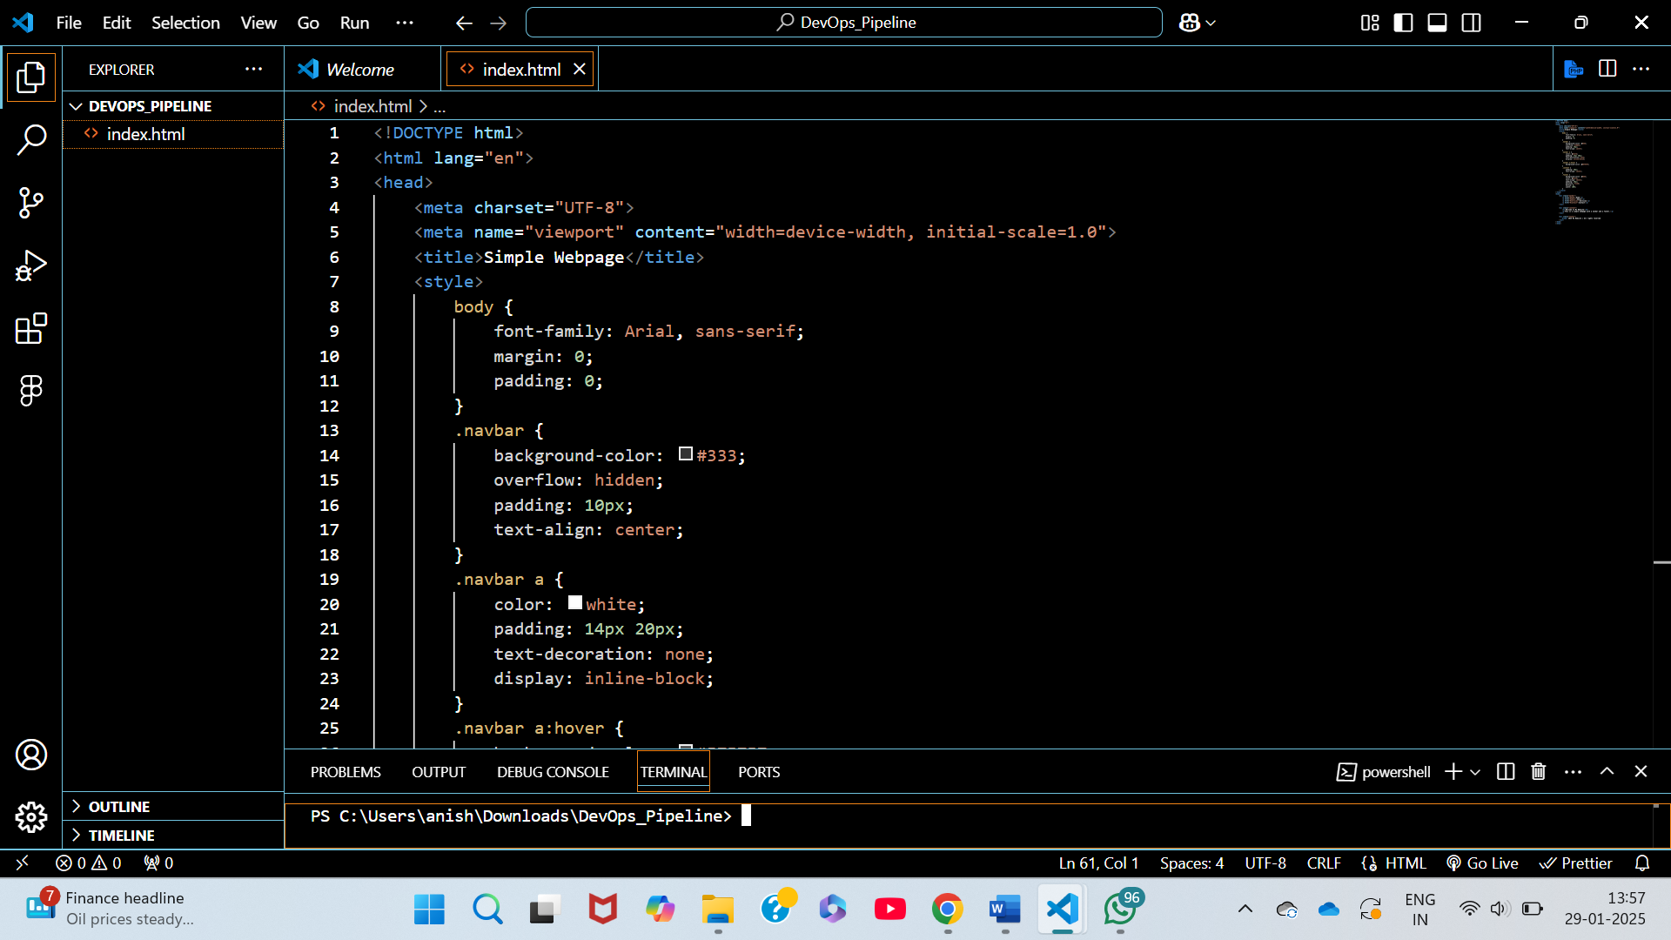

1. Add the index.html file in the repository.

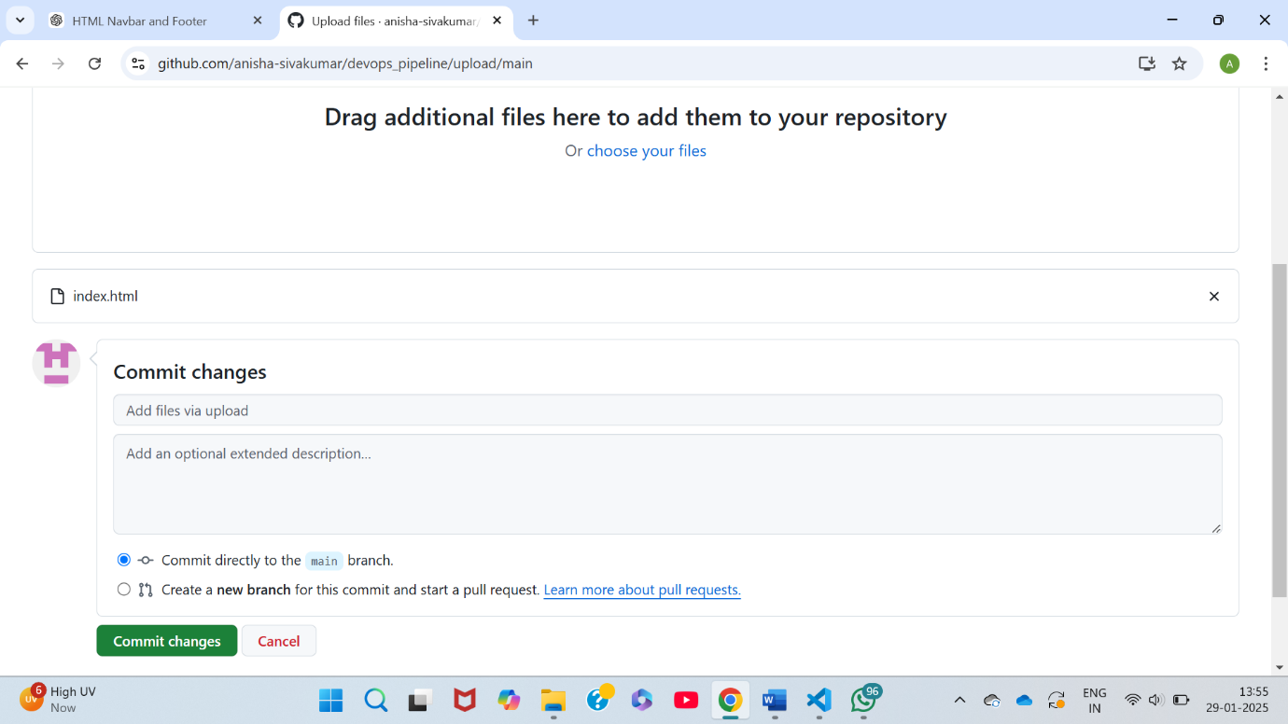

1. Navigate to the Settings => Developer Settings => Personal Access Token => Classic Token.

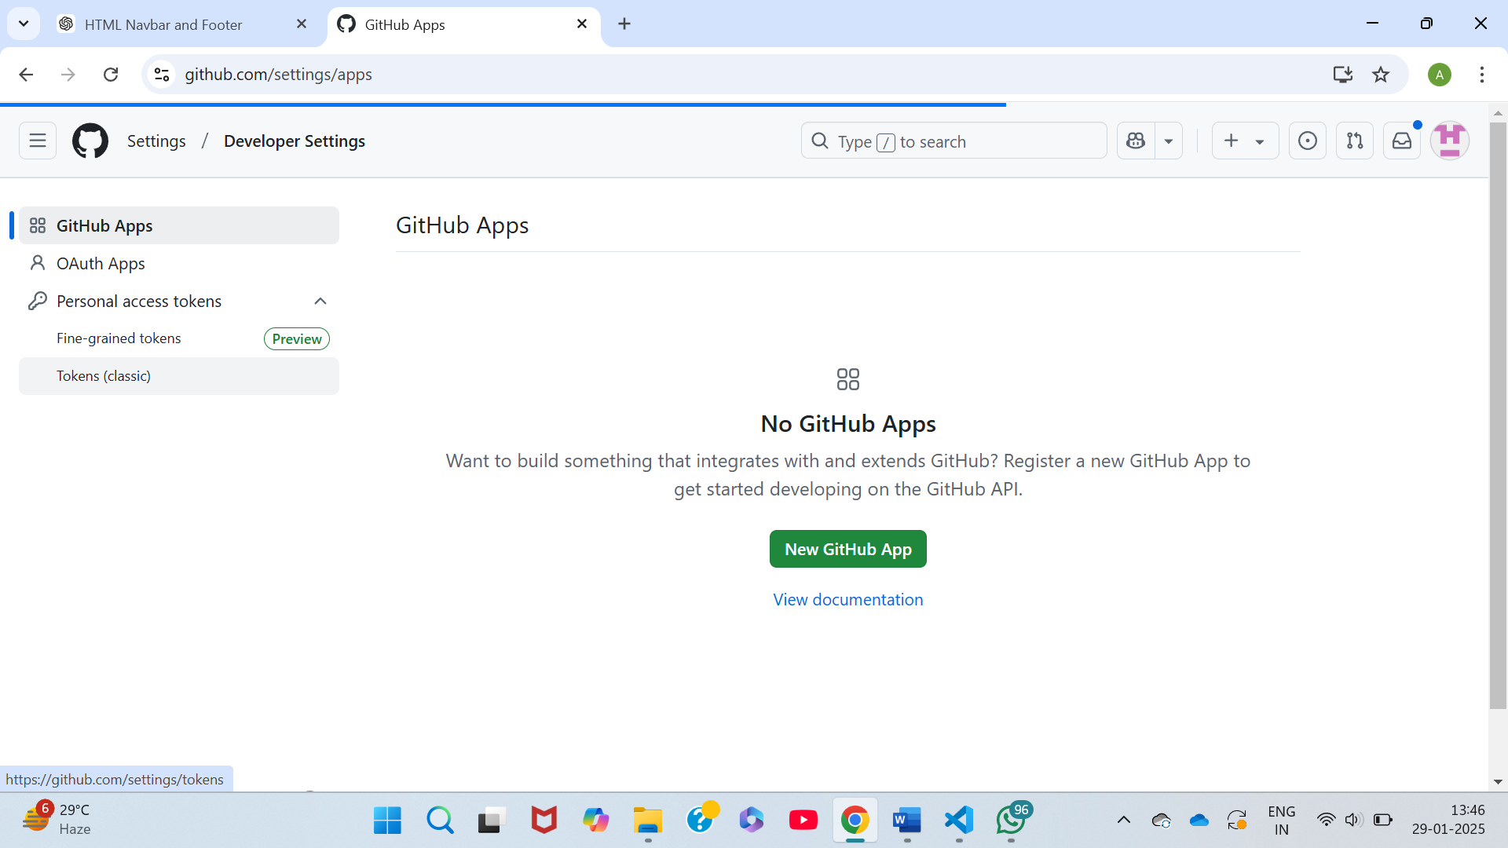

1. Click on generate new token.

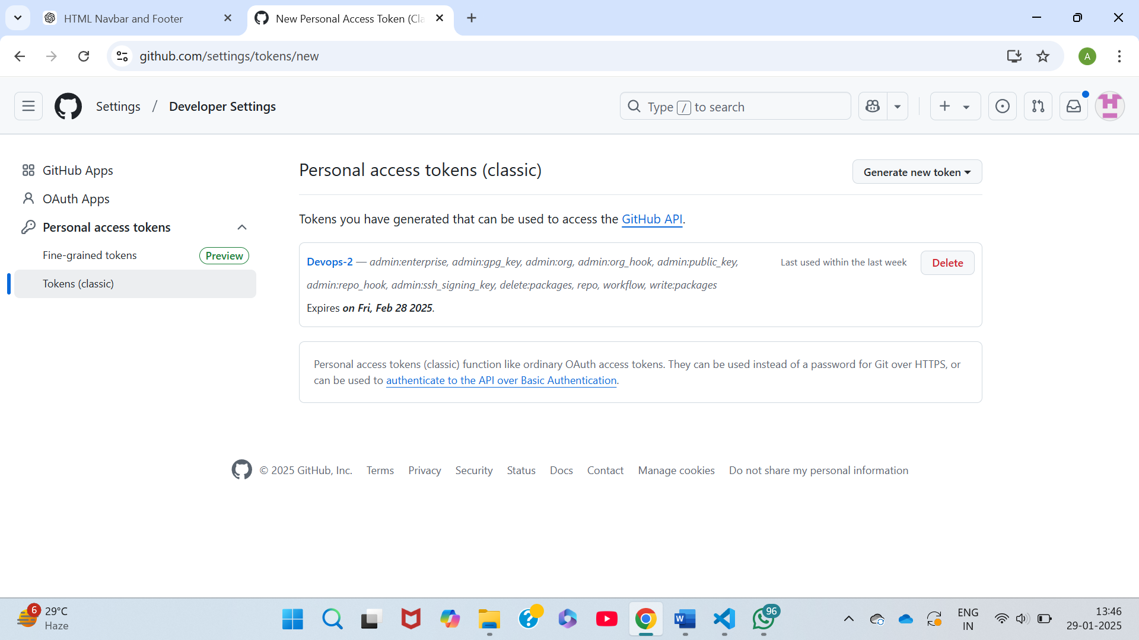

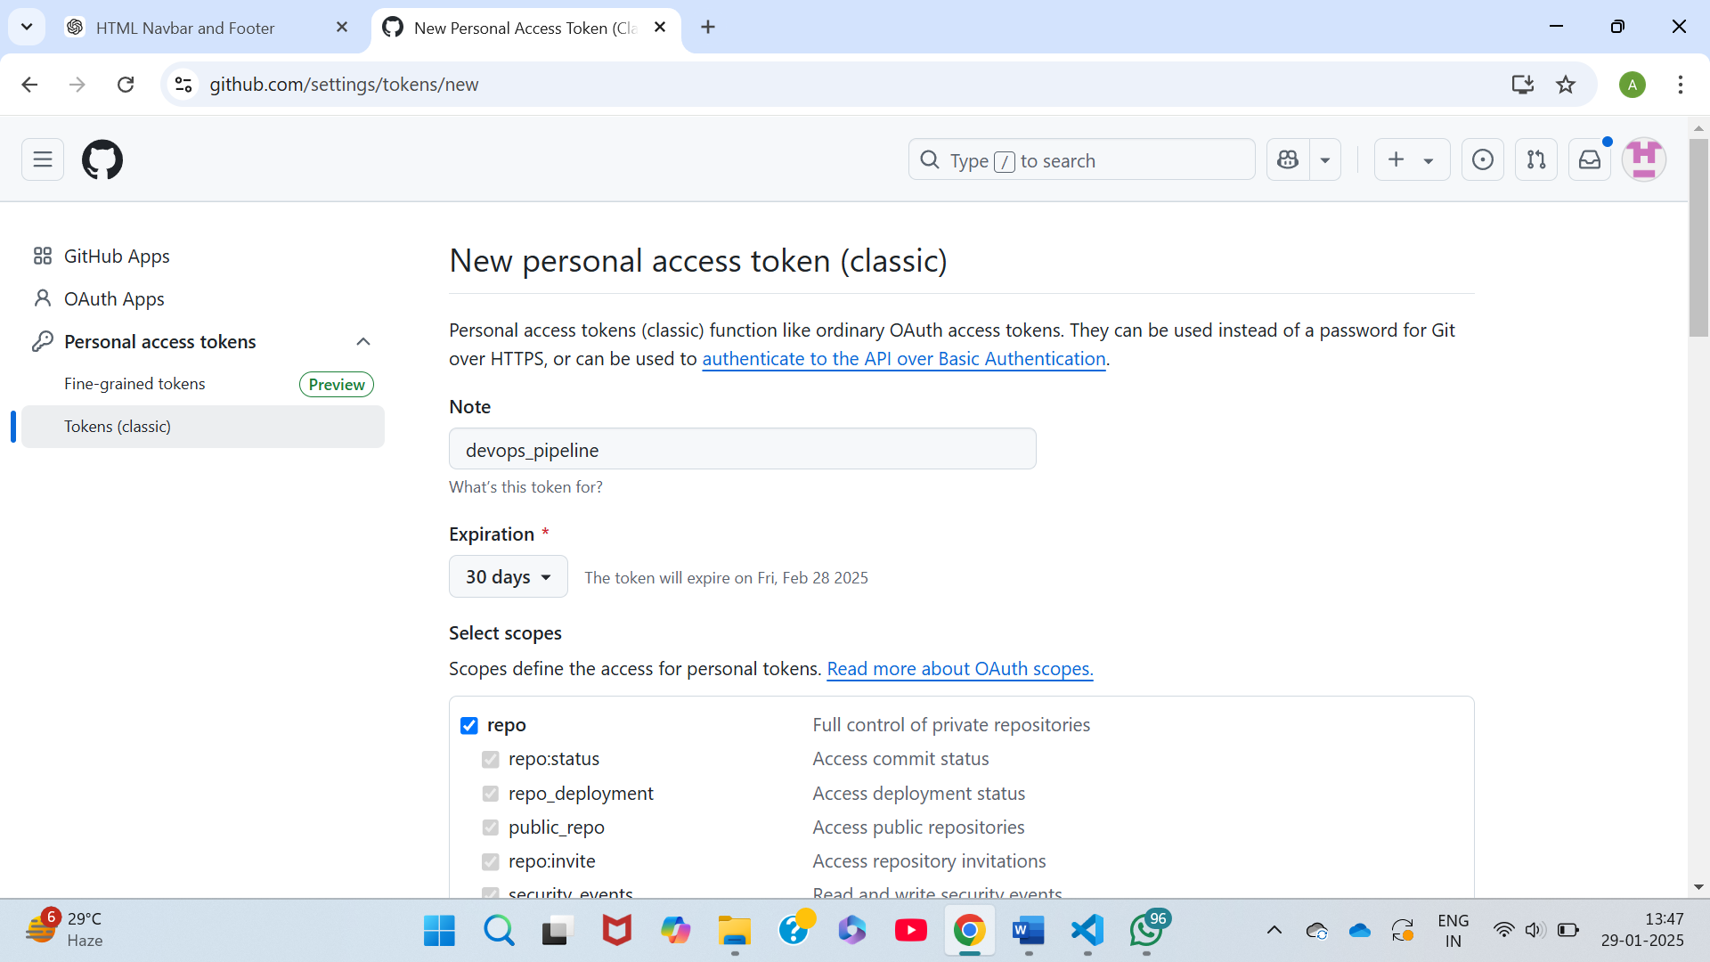

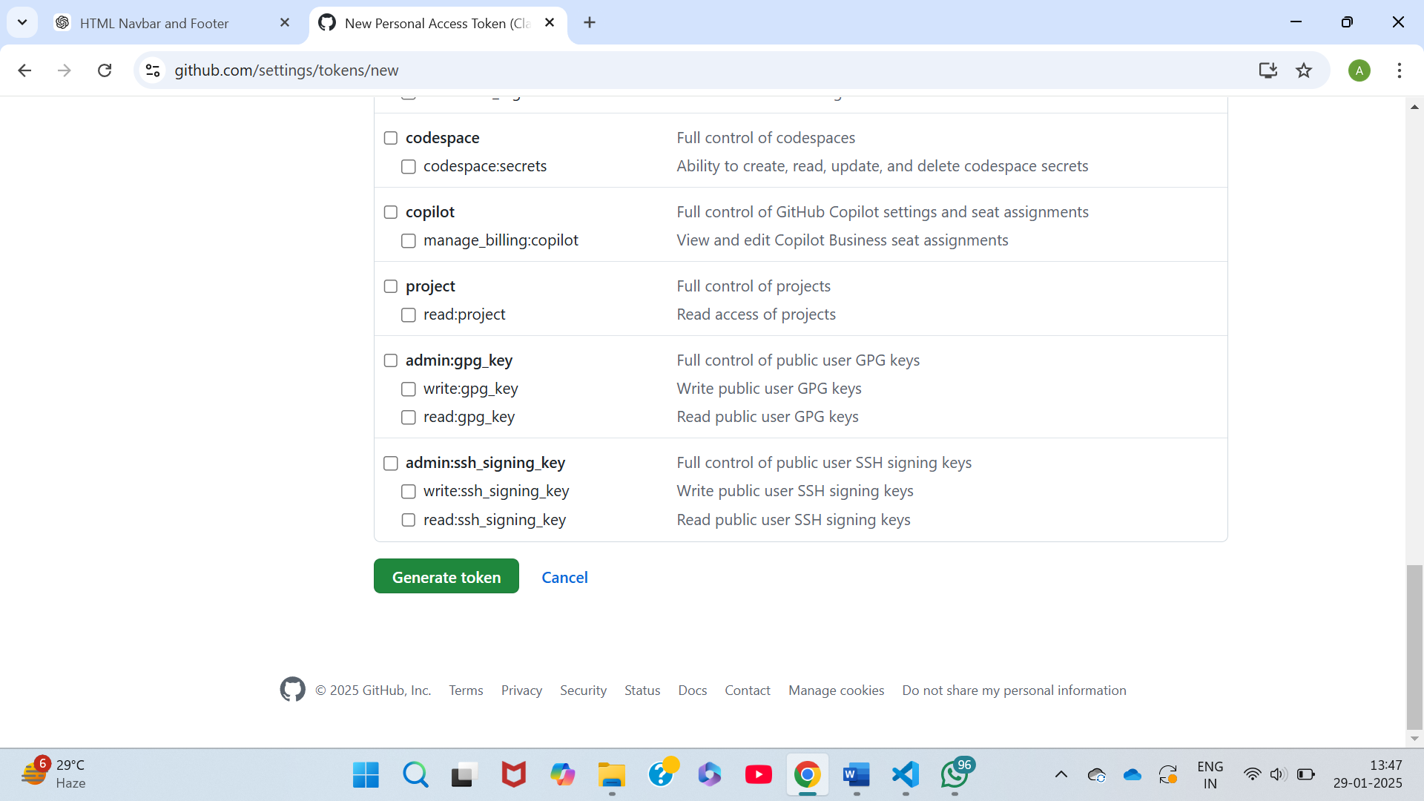

1. Copy the token.

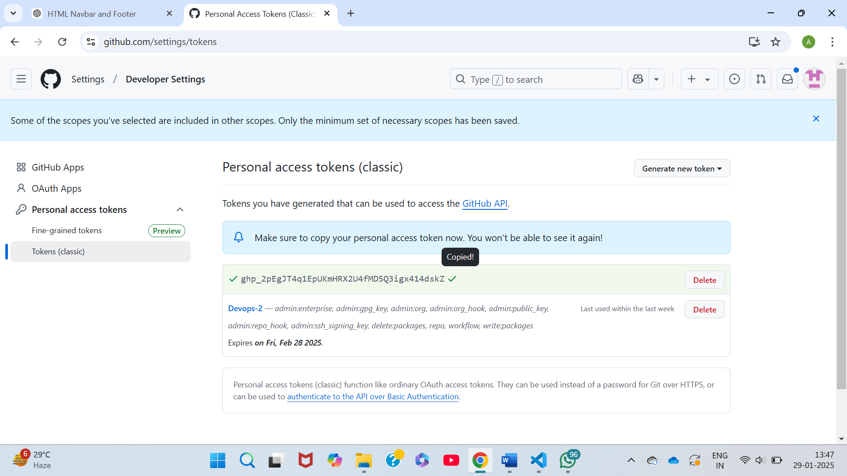

1. Navigate to the Settings of the Repository.

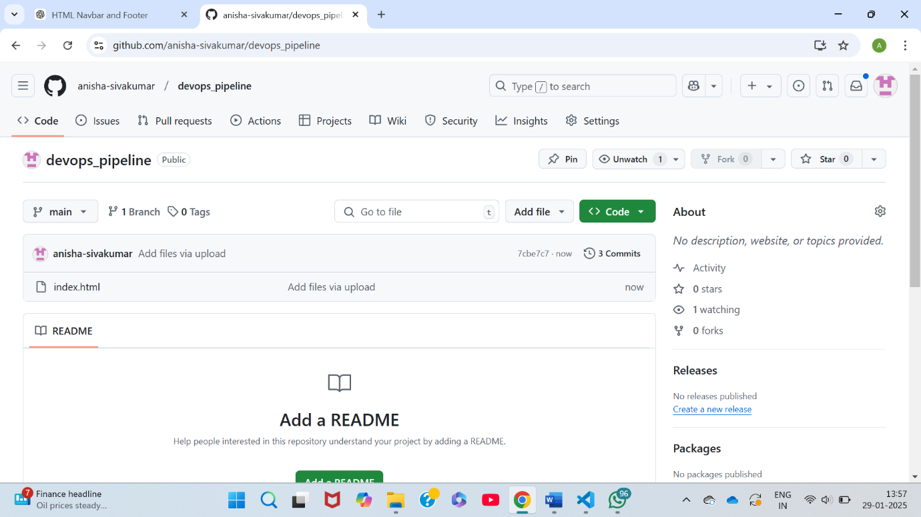

1. Under the Security, Click on the Secrets and Variables.

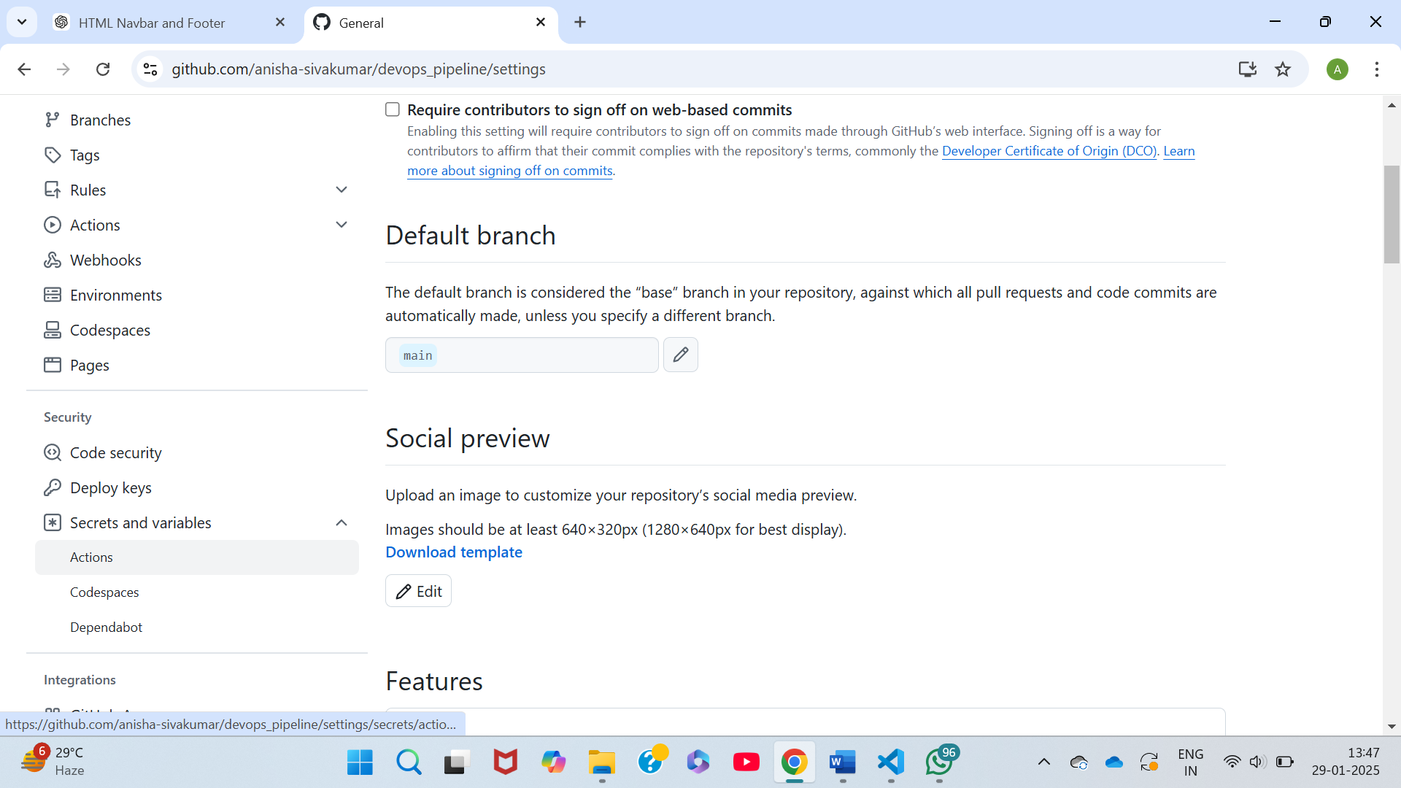

1. Click on the “New repository secret”.

1. Name the secret key.

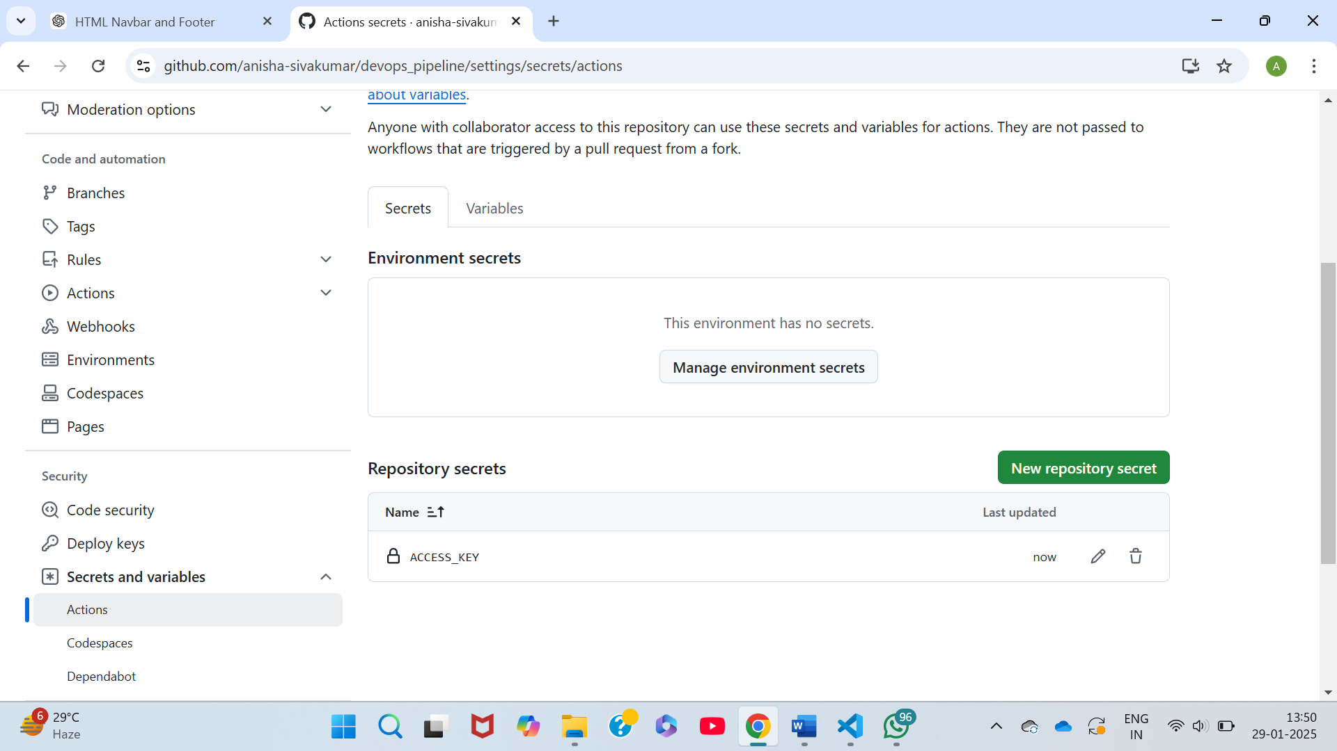



1. Create the directory as follows:

.github/workflows/main.yml

main.yml:

name: CI/CD for HTML Page

on:

push:

branches:

- master

jobs:

# Build Job

build:

runs-on: ubuntu-latest

steps:

- name: Checkout Code

uses: actions/checkout@v3

- name: Install Dependencies

run: |

# Assuming you don't have any dependencies for a basic HTML page, we can skip this step.

- name: Upload artifact to enable deployment

uses: actions/upload-artifact@v3

with:

name: html-file

path: |

./index.html

# Deploy Job

deploy:

needs: build

runs-on: ubuntu-latest

steps:

- name: Download artifact

uses: actions/download-artifact@v3

with:

name: html-file

path: ./html

- name: Deploy to GitHub Pages

uses: peaceiris/actions-gh-pages@v3

with:

github_token: ${{ secrets.ACCESS_KEY }} # Use the default GitHub token for authentication

publish_dir: ./html

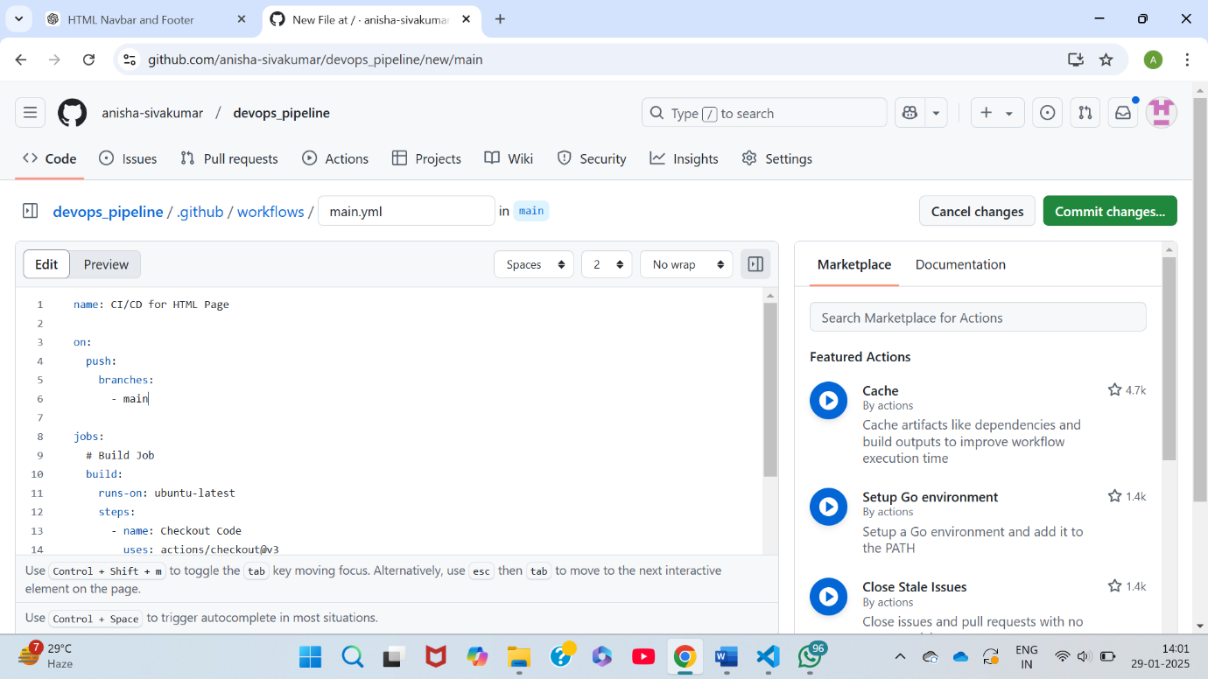



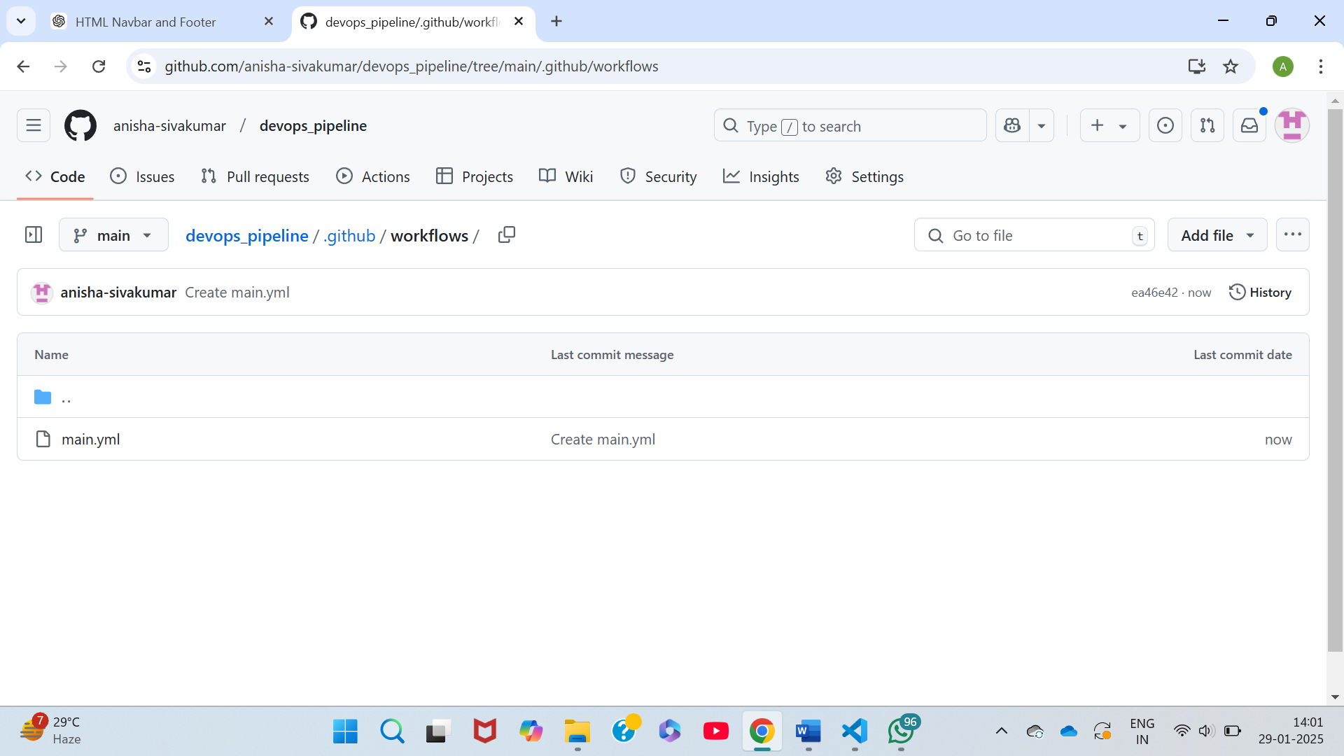

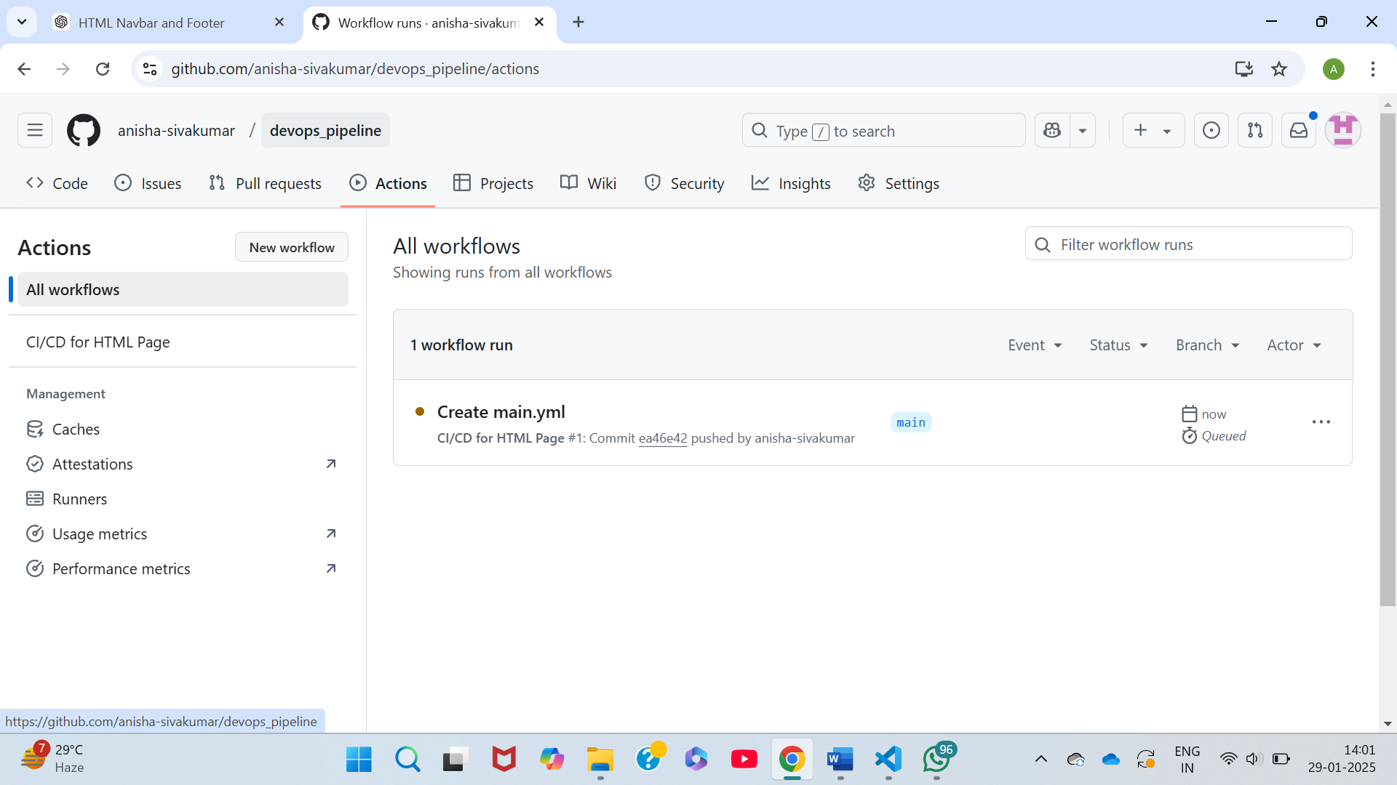

1. Click on the Actions.

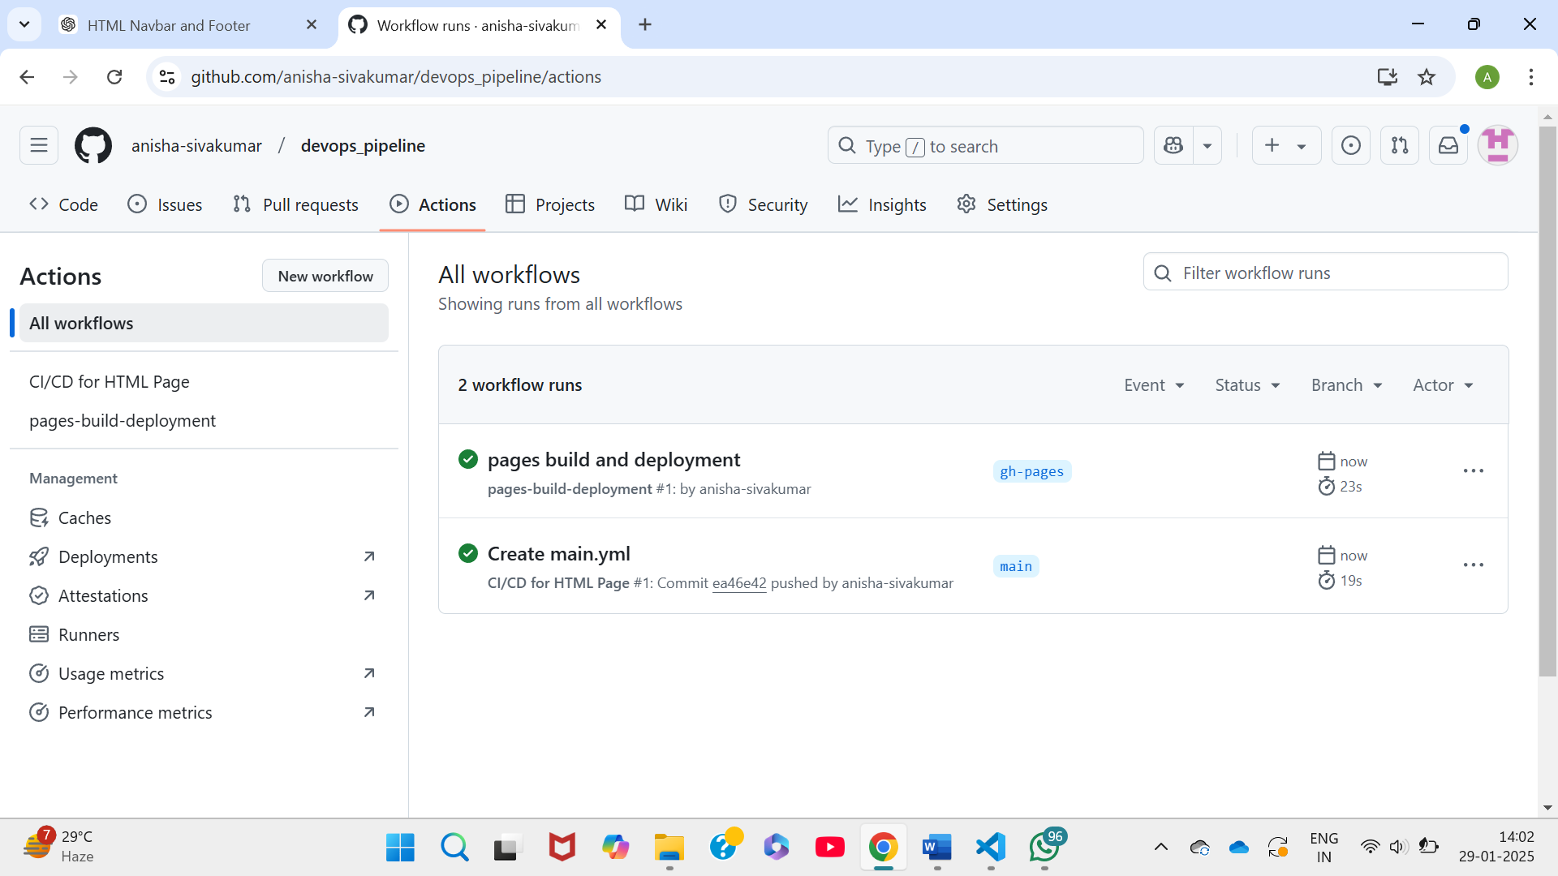

1. When you click on the link generated in “deploy”, the content of index.html file is shown.

